#include <stdio.h>
#define PLASTIC_POINTS 10
#define PAPER_POINTS 5
#define METAL_POINTS 15
void displayMenu();
int calculatePoints(int plastic, int paper, int metal);
void displayReward(int totalPoints);
int main()
{
char name[50];
int plasticQty, paperQty, metalQty;
int totalPoints;
printf("=====================================\n");
printf(" RECYCLE POINT REWARD SYSTEM\n");
printf("=====================================\n");
printf("Enter your name: ");
scanf("%s", name);
displayMenu();
printf("\nEnter plastic items count: ");
scanf("%d", &plasticQty);
printf("Enter paper items count: ");
scanf("%d", &paperQty);
printf("Enter metal items count: ");
scanf("%d", &metalQty);
totalPoints = calculatePoints(plasticQty, paperQty, metalQty);

printf("\n-------------------------------------\n");
printf("User Name : %s\n", name);
printf("Total Points : %d\n", totalPoints);
printf("-------------------------------------\n");

displayReward(totalPoints);

printf("\nThank you for recycling!\n");
printf("=====================================\n");

return 0;
}
void displayMenu()
{
printf("\nRecyclable Items and Points:\n");
printf("1. Plastic - %d points per item\n", PLASTIC_POINTS);
printf("2. Paper - %d points per item\n", PAPER_POINTS);
printf("3. Metal - %d points per item\n", METAL_POINTS);
}
int calculatePoints(int plastic, int paper, int metal)
{
int points;
points = (plastic * PLASTIC_POINTS) +
(paper * PAPER_POINTS) +
(metal * METAL_POINTS);
return points;
}
void displayReward(int totalPoints)
{
if (totalPoints >= 500)
{
printf("Reward: 🥇 Gold Reward\n");
}
else if (totalPoints >= 300)
{
printf("Reward: 🥈 Silver Reward\n");
}
else if (totalPoints >= 100)
{
printf("Reward: 🥉 Bronze Reward\n");
}
else
{
printf("Reward: Keep Recycling to Earn Rewards!\n");
}
}

Output:
Step 1:
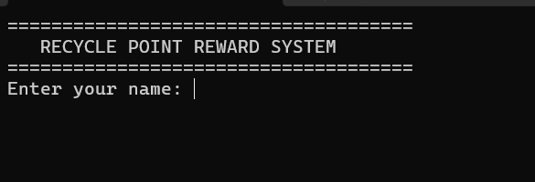

Step 2:
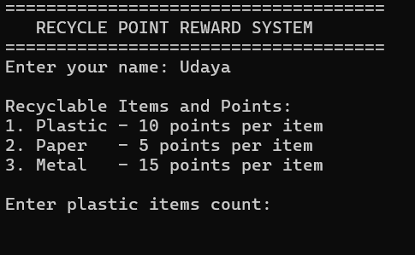

Step 3:
